#
# 20210708
# Turn on/off lines wrapping.
# Click right mouse button on area with line numbers.
# https://stackoverflow.com/questions/38585204/pycharm-to-toggle-soft-wrap-in-code-editor
#
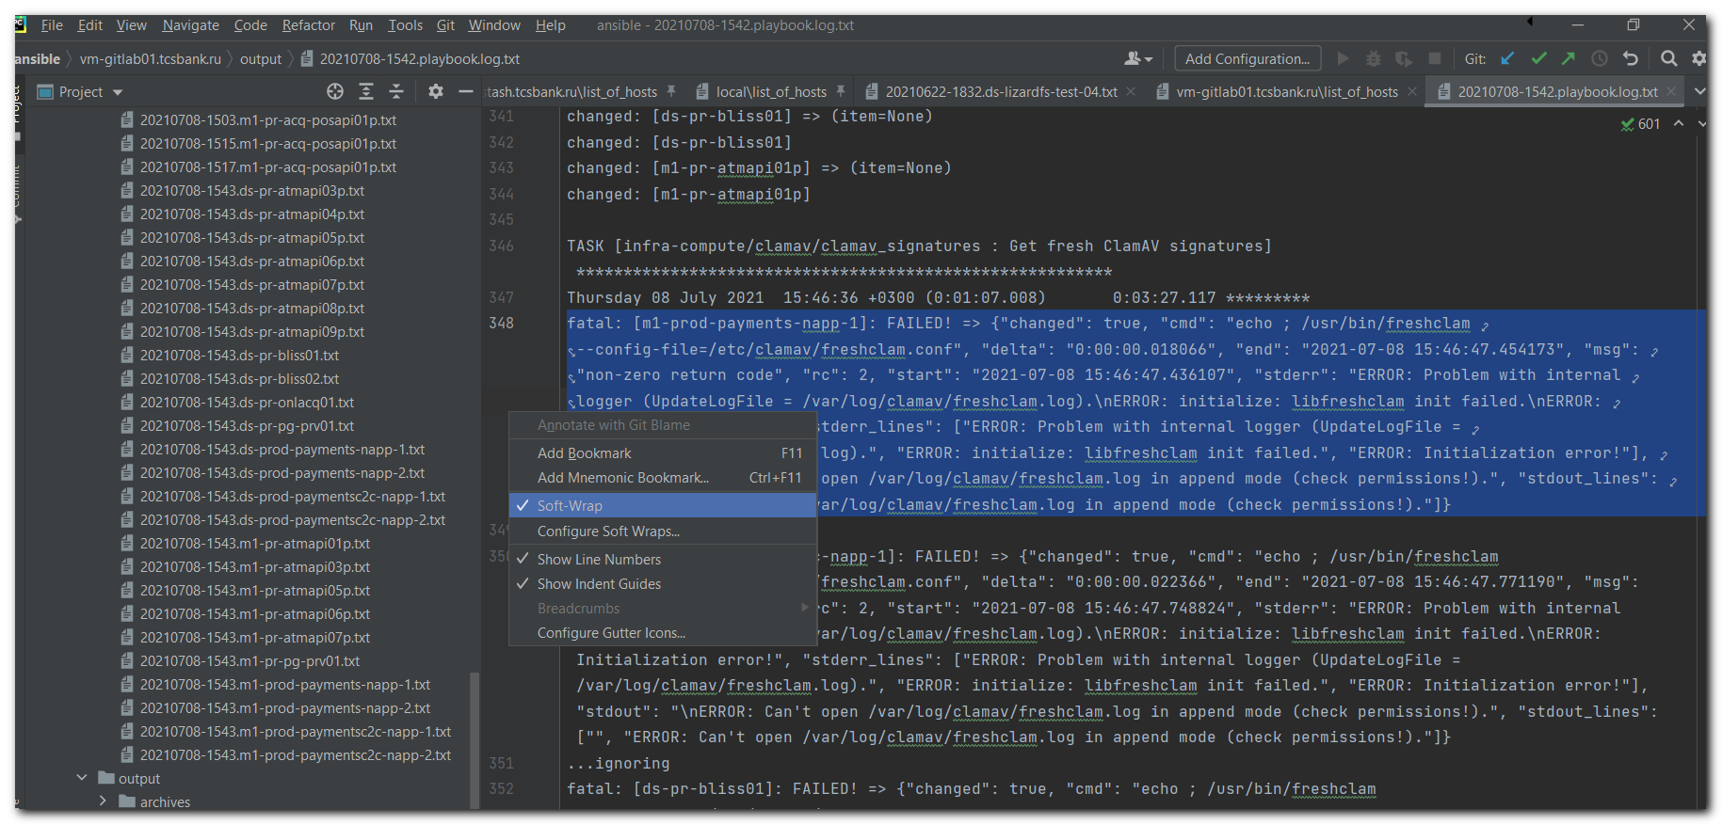

# Another place.
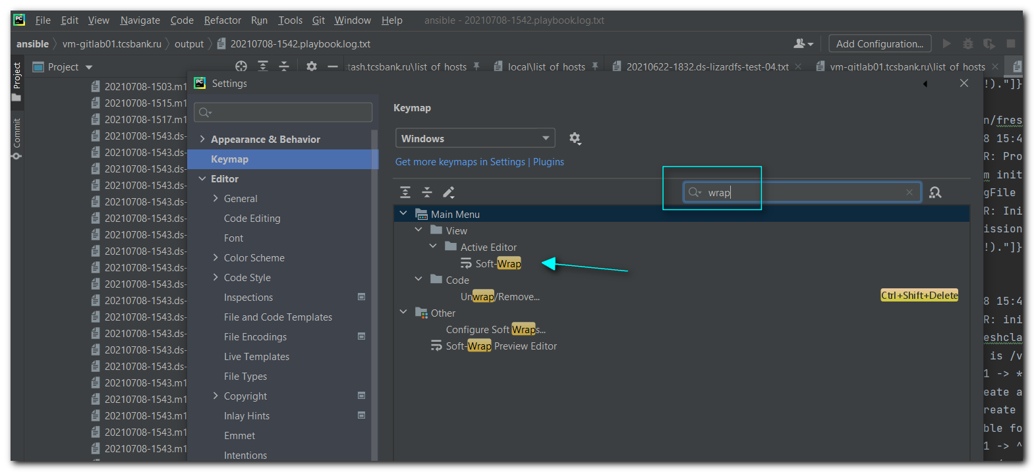
# And another one place.
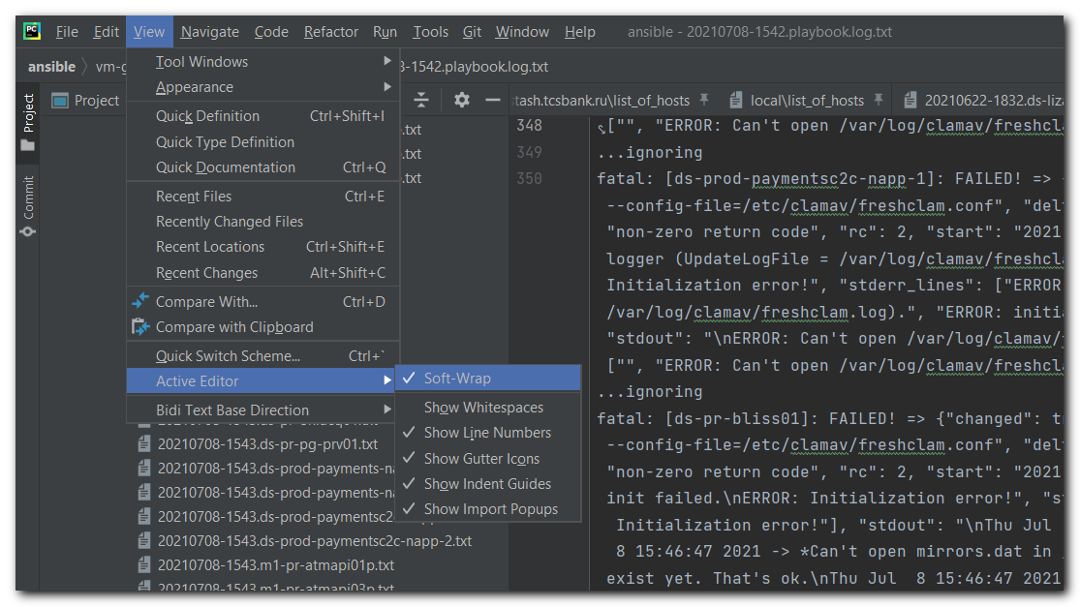

#
# 20210330
# On fresh installation PyCharm Community Edition I only installed one plugin: IdeaVim.
# And when I started new project, I just chose only directory folder c:\data\work\ansible and chose option not add existed file into the project. And that's it. And of course, before - I moved out .idea and .git folders from project folder c:\data\work\ansible.
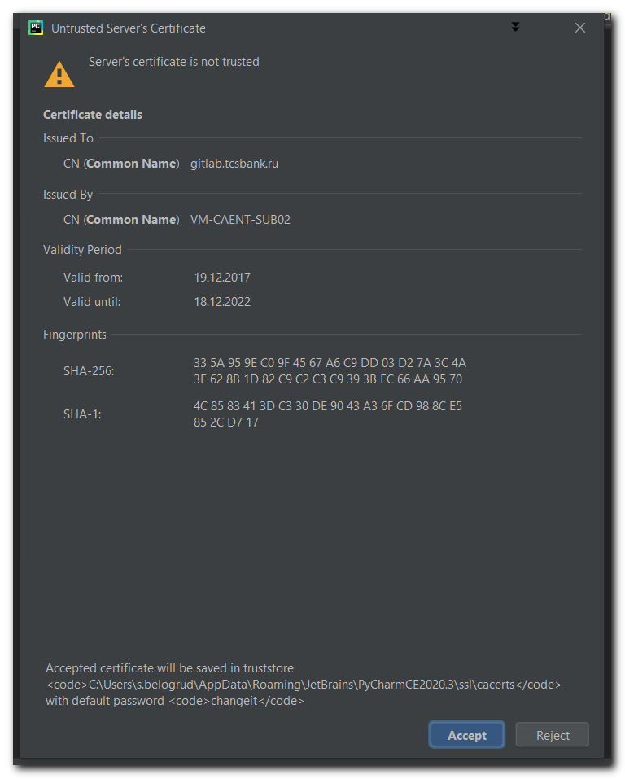
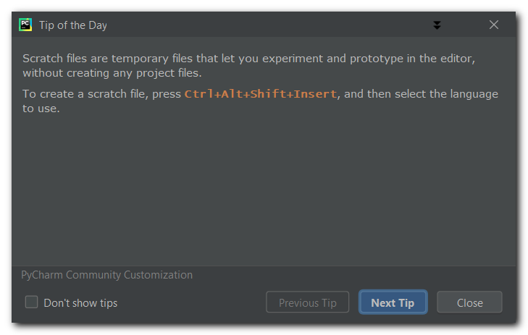
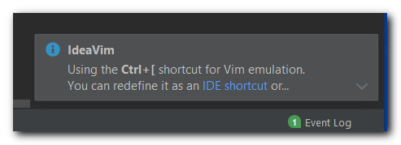

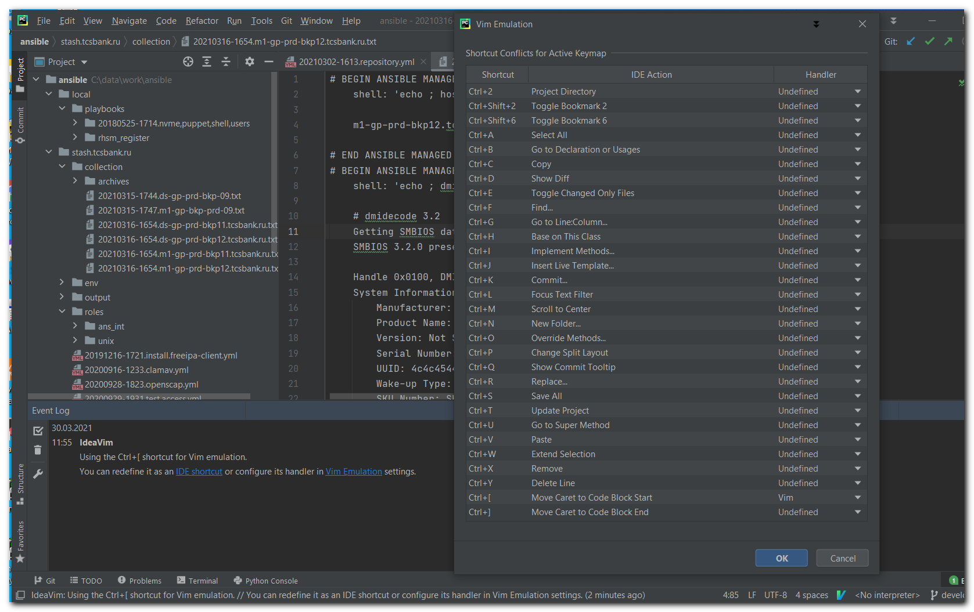

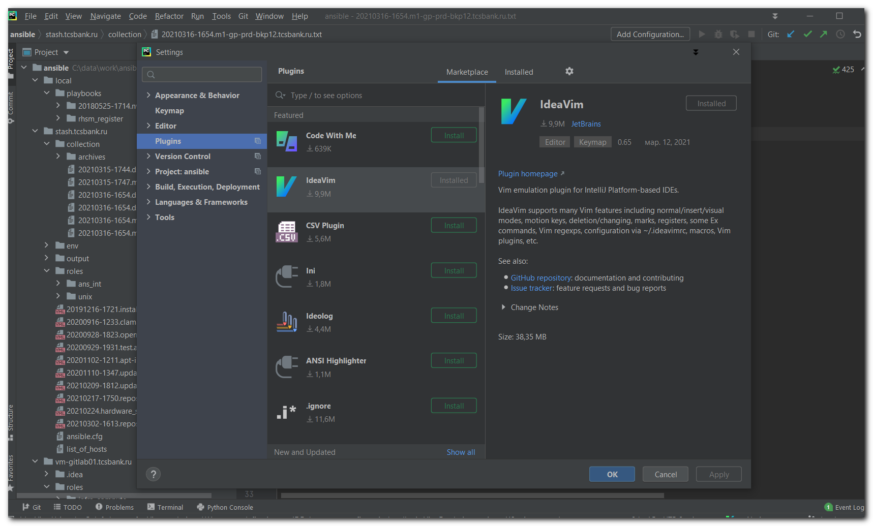

#
# 20210330
# This is require to work "Escape" after in editor was pressed "Ctrl + [" buttons.
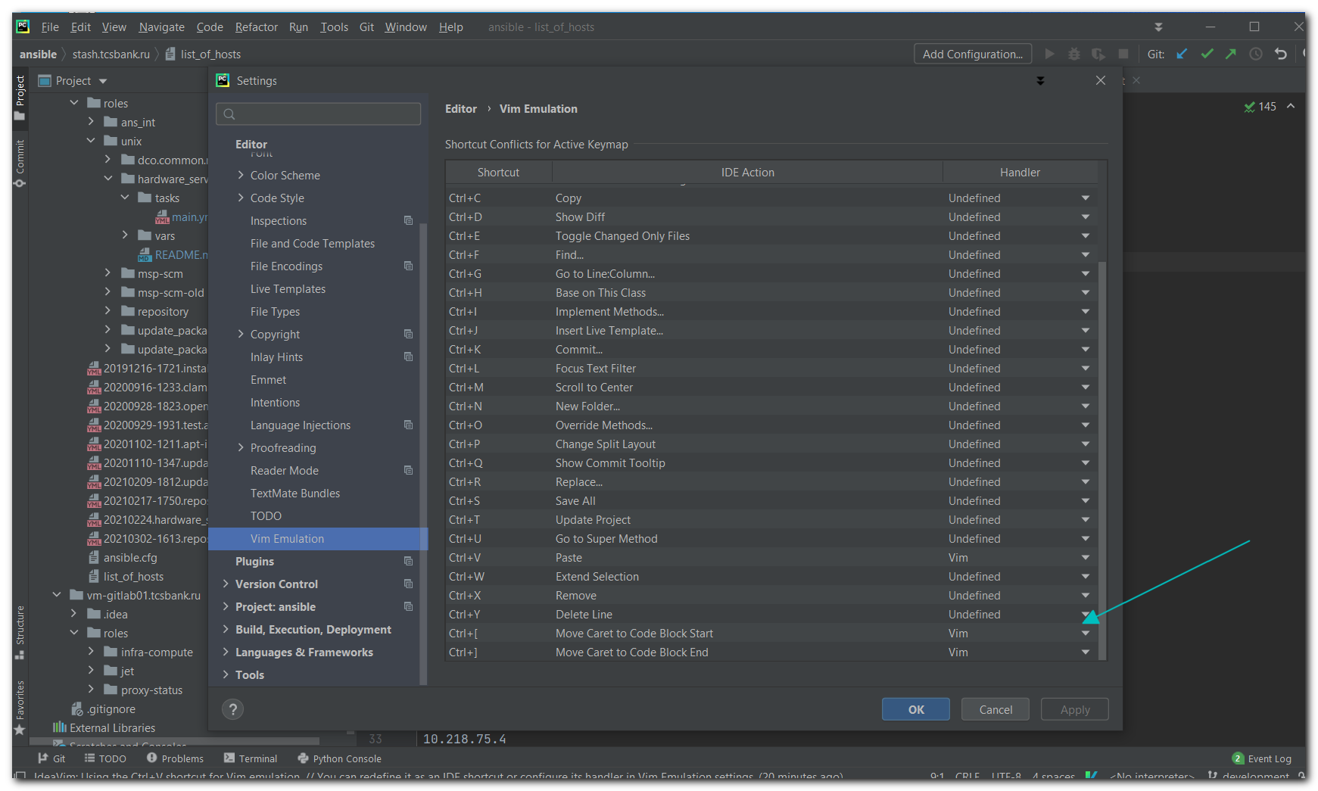

#
# And this configuration I have on my desktop in office.
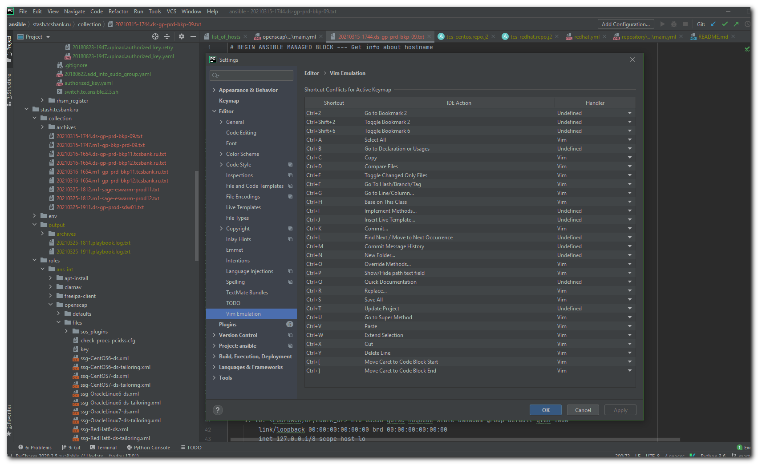

Oct 29, 2021
Every time, when I restart PyCharm I received follow messages: "Unsupported Git Version 2.9.0. At least 2.19.2. is required".
Here I found where it came from. I pushed the Test button and get this message here.
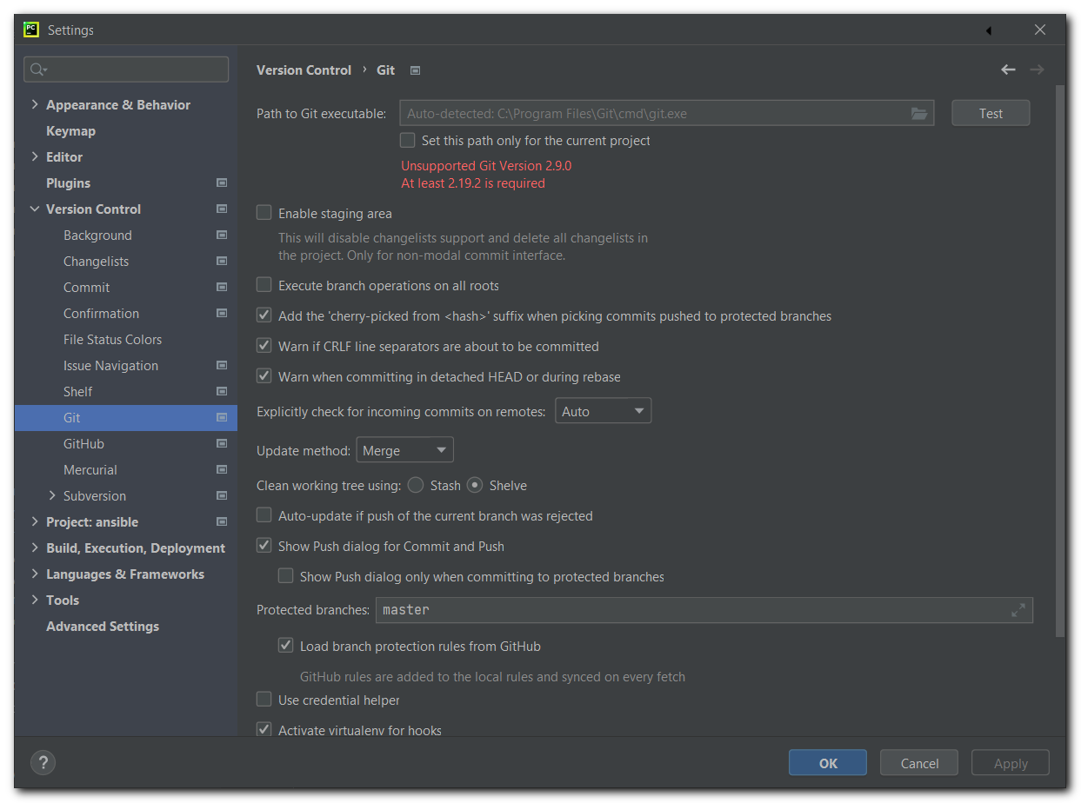

# In MobaXterm I found follow paths to Git.
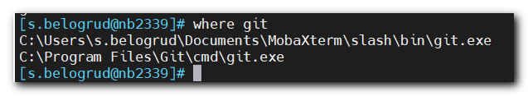
# I attempted execute it from Power Shell CMD window - but received only error messages.
# When I tried execute them from MobaXterm - I received trash in terminal window.

# After all I paste the first path into the field and pressed Test button. Then I received follow text and link to "Download and Install"
# I pushed the link.
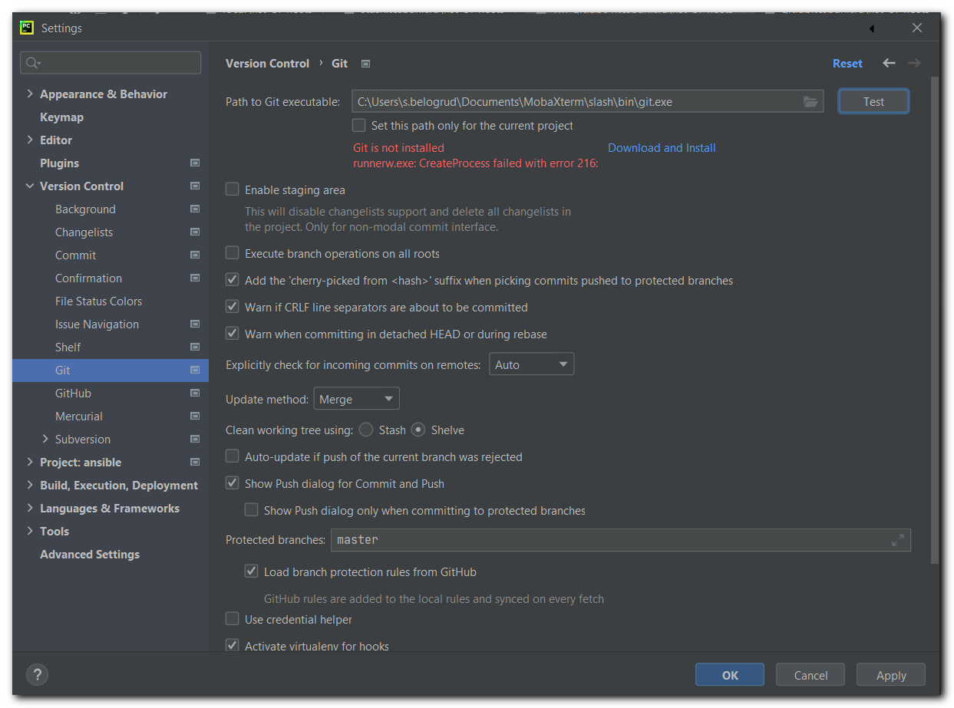
# Then appeared a window with confirmation to install Git.

# Problem gone... Hooraah! :-)
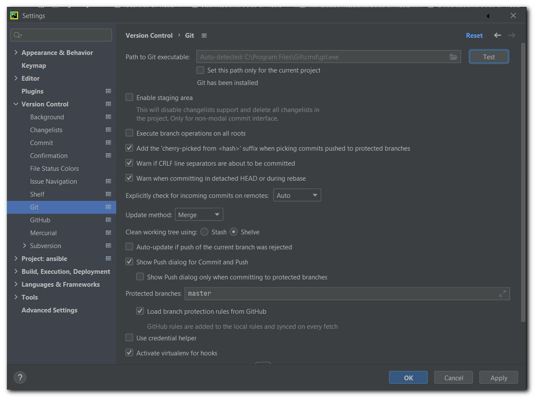

# I found pictures same as it was in the window, when was request fot Git installation.
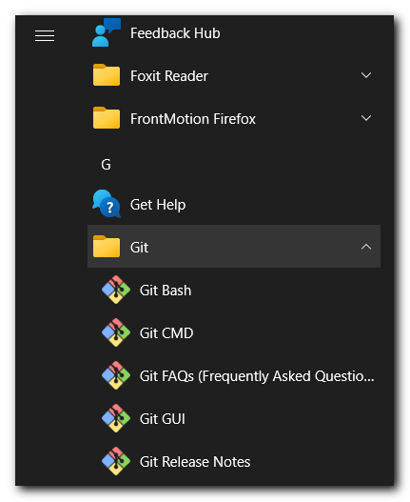

Oct 29, 2021
Появлялось сообщение при запуске.
Это язык программирования Nim. Я его не использую. Отключил плагин.
